

Assignment Documentation on ECS Terraform

Ritesh, Dated- 14.11.2022

r

#### DESCRIPTION

* In this post I am going to explain how to build the infrastructure on AWS with Terraform to implement a CI / CD pipeline for ECS / Fargate.
* The Architecture consists of a VPC with 2 public subnets in different Availability Zones. The desired tasks are 2 and each task is deployed on each public subnet with Fargate and each task belongs to the same ECS service.
* An Application Load Balancer is used to balance the load between the two tasks.

**ARCHITECTURE**

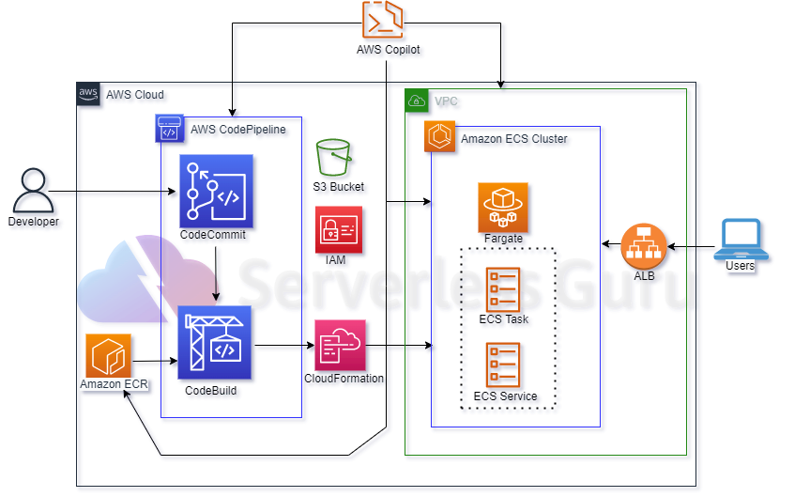

**STEPS**

**STEP 01 –** Create a IAM Role and Policies

* It’s a necessary to create a IAM role and Policies to allow access to ECR to push and pull the images of Docker in the repository of ECR.
* Allow permission to access S3 bucket to store artifacts.
* Public subnet route table.
* Security Group created for ECS Sevice.

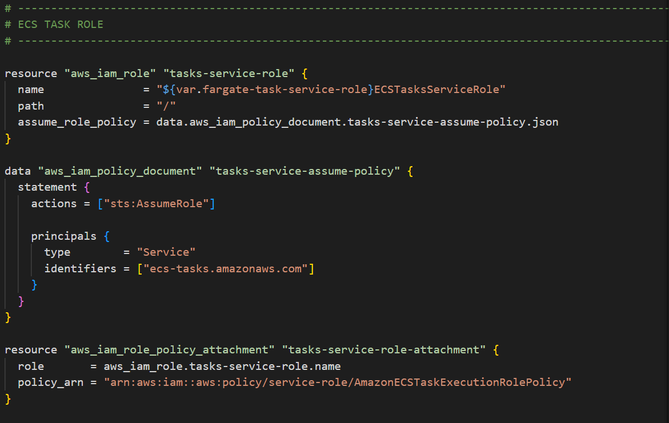

**STEP-02 –**

* Creating a vpc,it has a subnet and an internet gateway.
* It is a private cloud computing environment contained within a public cloud. Essentially, a VPC provide logically isolated environment in the cloud inside the VPC we have created different services such as,

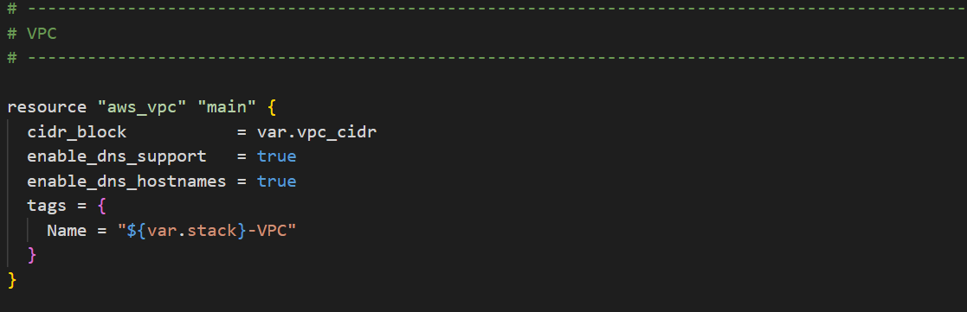

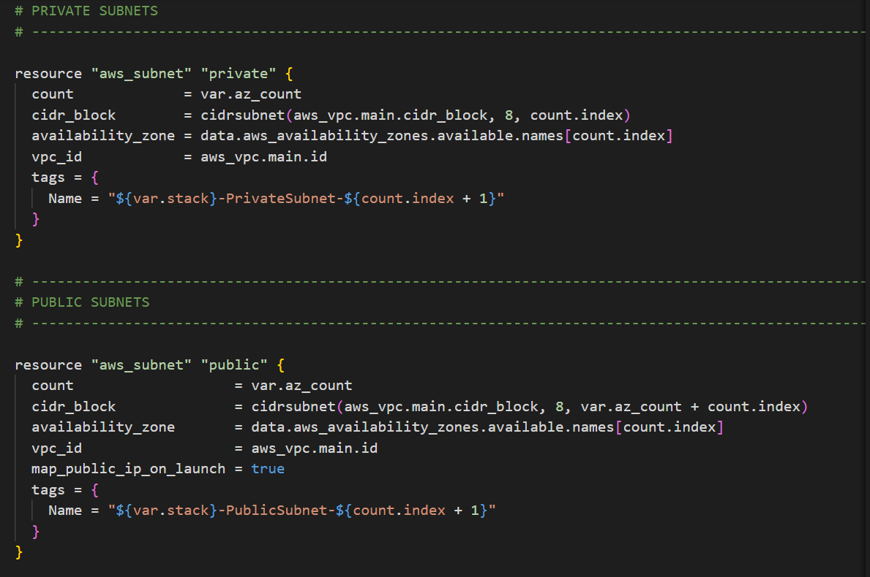

* Creating a Load balancer where the Target group and Listener are created inside the Load Balancer.
* The file contains the Resource of the application load balancer which distribute the load among the different servicesapart form it consists of the target groups which target the two subnet created at different availability zone and a listener group.
* 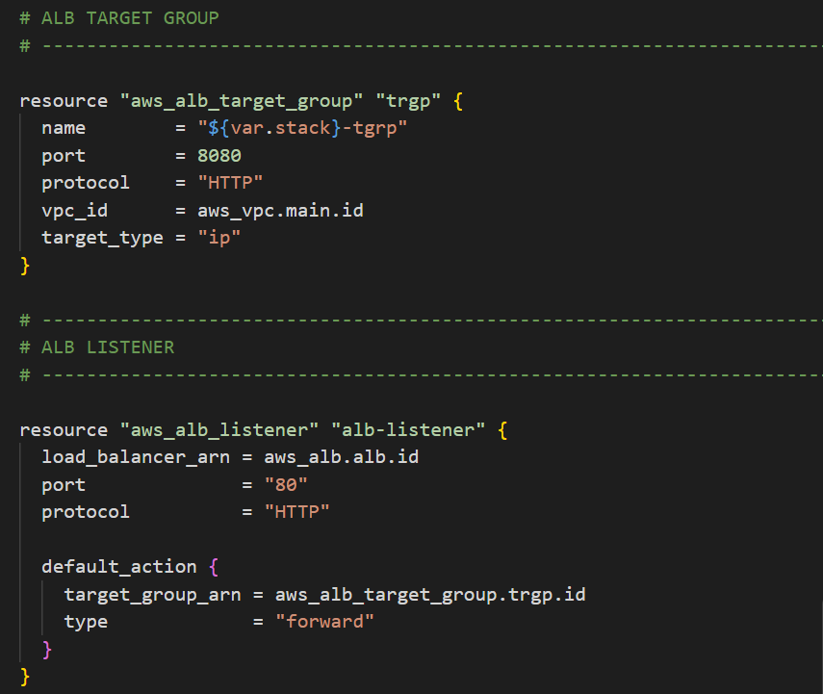

**STEP-02 –**

**ECS AND ECR**

ECR Repository

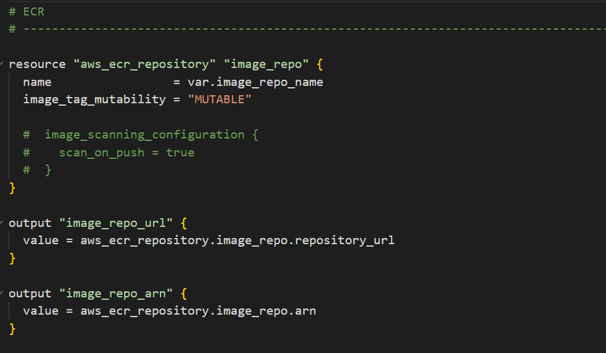

ECS Cluster

